

*Candidate for Department of Breast Oncology*

**Sangeetha Reddy, MD, Msci**

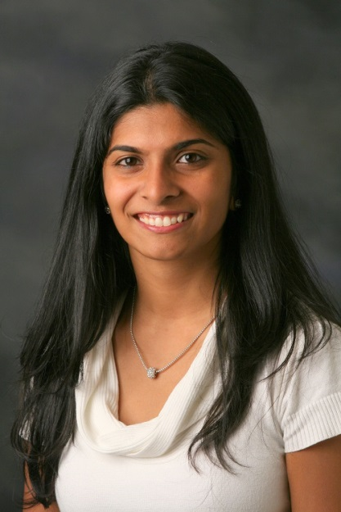

**Research Instructor, Department of Breast Medical Oncology**

**The University of Texas MD Anderson Cancer Center**

*Presents:*

***“Targeting the Tumor Immune Microenvironment of Breast Cancers”***

***Monday, January 22, 2018***

***12:00 PM – 1:00 PM***

**Location: McKinley Gruden Huddle Room**

*For further information contact Lauren Hobby x3319*